SUPPLIES AND RESTOCKING

– Receiving Dock

The Mission Bernal Campus loading dock is located on Level 1 from the Main Lobby through Corridor 1000 just past the Service Elevators, or from the exterior off the Cesar Chaves St.

Vehicle traffic will use the loading dock ramp, and foot traffic should use the door just to the East of the main loading dock vehicle entrance.

* The Street Address of the loading dock will remain the same as that of the former St. Luke’s Hospital.
* The loading dock is on the small side and the truck length limit is 35 feet from front bumper to the rear bumper, longer trucks will not fit.
* There are two areas of the loading dock, a clean area and a soiled area. All clean supplies, food and linen will enter through the clean area. All soiled linen, waste, used/ soiled rental equipment, and the trash compactor will be managed through the soiled loading dock area.
* Drivers of all vehicles must shut off the engines while parked within the dock areas.

Note: No personal packages should be sent to your work location. Only hospital related packages, personal packages will not be signed for by receiving staff.

Supply Chain & Medical Gas Area (Central Distribution and Receiving)

CPMC Mission Bernal Campus is welcoming the St. Luke’s Distribution staff. The Supply Chain team is responsible for the replenishment of Medical Gases which will be housed centrally in the Medical Gas storage room on Level 1, accessed directly off the loading dock in room 1518. The supply chain area is also located on Level 1 adjacent to the loading dock. Staff, supplies, and receiving will be staged here to support a Low Unit of Measure (LUM) Just in Time (JIT) distribution model. The floor plan room number for this area is 1522.

Supply Chain Stat Supply Requests (Central Distribution and Receiving)

The main departments of Supply Chain include: Central Distribution (supply) and Receiving.

* Normal Business Hours Central Distribution: **x86626**
* Normal Business Hours Receiving**: x86901**
* Supply Chain Intranet requests: <http://apps.insidecpmc.org/CPMC_SRQ/servlet/LoginServlet?cpmc_role_id=180> Sample form below:

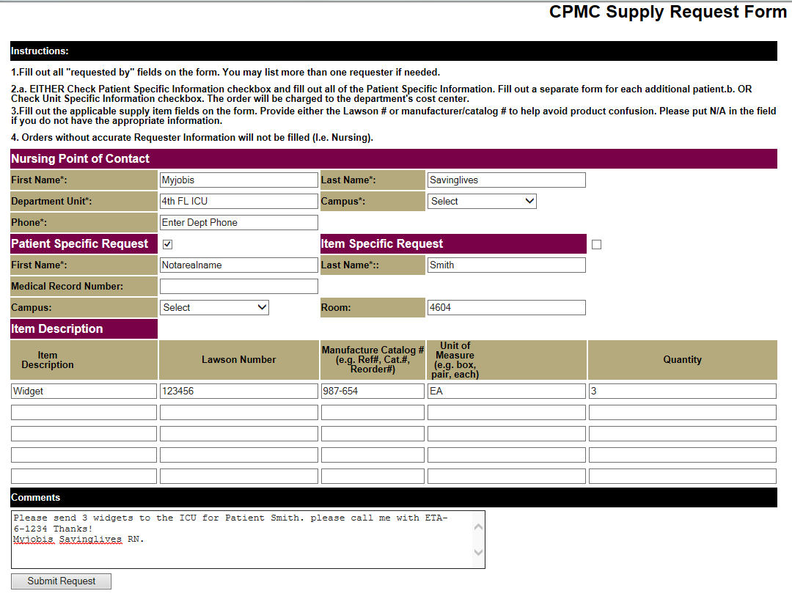

* Supply Chain Staff will be onsite between the hours of 7AM-16:30 M-F.
* Par Levels for supplies on the units will be calculated for 4 days of inventory on hand.
* For supply needs during evening and weekends when Supply Chain staff are not onsite, unit staff can contact the Nursing Supervisor who will have access to the Distribution storage area as per current process.
* Supply Chain Staff will manage the restocking and storage of Code Blue/ Broselow resuscitation carts.

Support Department – Supply Chain (Central Distribution and Receiving) The Code Blue Cart quick reference guide can be found here: <http://mysutter/bay/CPMC/About/News/Department%20Newsletters/CrashCarts.pdf>

* Broselow quick reference guide can be found here: <http://mysutter/bay/CPMC/Clinical/Nursing/Need%20to%20Know/BroselowCrashCart.pdf>

BD (WHAT IS BD?) Pyxis Supply Use and Instructions

* The Pyxis Supply management system will be used in a combination of locked and unlocked cabinets.
* Locked Cabinets will be utilized for securing IV solutions, intravenous or interventional supplies, and patient chargeable supplies.
* Note that due to space constraints, some supplies that do not meet the criteria of heightened security may also be stored in these locked areas.
* Items that are Patient chargeable will have a Pyxis button label used for billing the supply to the patient record. That button looks like this: 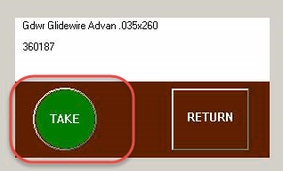
* Items that are not patient chargeable will have a label that looks like this: 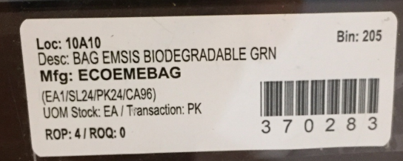
* Pyxis Supply Dispensing and revenue capture will represent nearly $400,000 in annual supply revenue at Mission Bernal Campus. Correct use of these devices is critical to maximizing the benefit of these systems. On the following page is a brief instructions for use:

Overview:

* Select the correct patient when dispensing supplies through the Pyxis to ensure charges are being captured and billed

**Step Action Activity:**

|  |  |
| --- | --- |
| **Log In to the Pyxis Supply Station**   1. Enter your **User ID.** 2. Enter your **Password.** 3. Place finger on **Scanner** to verify. |  |
| **Take - Return**   1. Select **Take – Return.** |  |
| **Subtitle (if needed)**   1. Select the correct **Patient’s Name** from the list.   **NOTE:** Do NOT select Floor Stock or a Generic Fake patient. **This is where the selection error occurs that leads to incorrect billing.** |  |
| **Choose Items**  After selecting the valid patient:   1. Choose all needed items by selecting the **Take** button on the shelf below the product.   **NOTE:** Pyxis and Epic automatically identify which items are chargeable and which items are not. The non-chargeable items will be filtered out and will not be applied to a patient’s bill. |  |

* Pyxis supply stations as well as wire shelving units will utilize a standard color coding and layout to make locating supplies more intuitive.
* Here is a sample of how this color coding will look:
* 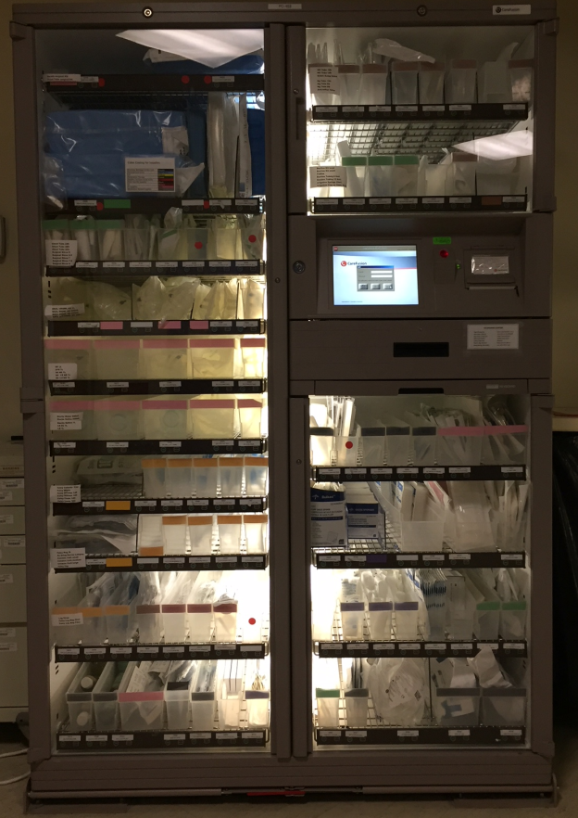 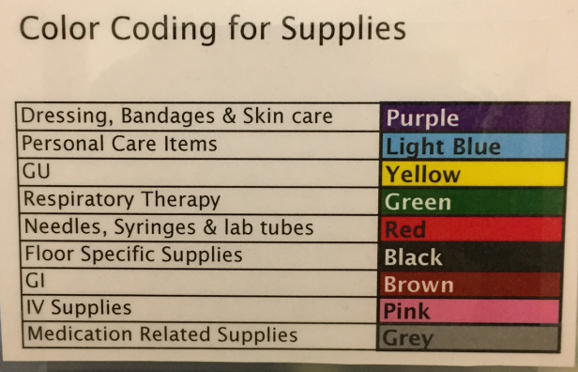

The color coding and supply layout standard is a general guide and is as follows

* Dressings Bandages and skin Care: Purple
  + Lower center
* Personal Care Items: light Blue
  + Not specified
* Urology: Yellow
  + Lower Left
* Respiratory Therapy: Green
  + Upper Left
* Needles, Syringes and Lab Tubes: Red
  + Far right central
* Floor specific supplies: Black or no color
  + Not specified
* GI supplies/ feeding tubes: Brown
  + Central Top
* IV Supplies: Pink
  + Left side central
* Medication related supplies: Grey
  + Not specified
* Supply Chain staff will Monitor supply levels and the automated supply system will generate refill requisitions to order inventory.
* Supply Chain will receive delivery from our primary distributor at 8PM Monday through Friday.
* Supply Chain will remove corrugated cardboard at the loading dock as per infection control policies, and deliver supplies to the Pyxis and supply cart areas throughout the hospital.
* Nurse Server carts are department specific and are non-standard storage options some departments use. Supply Chain does not manage or replenish supplies on these carts.

Equipment Cleaning

* Movable Medical equipment such as IV pumps, SCD pumps, etc. will be tracked, cleaned and transported by Equip/ Bio-Med staff. In some cases specialty equipment solely used by a specific area will be kept and maintained by that area owner.

AeroScout Equipment Tracking

* AeroScout is the chosen RFID (Radio Frequency Identification) equipment location system.
* Essentially equipment that moves will be targeted for RFID tracking.
* Equipment that will have RFID tracking includes but is not limited to:
  + Beds
  + Wheelchairs
  + Gurneys
  + IV pump brains & modules
  + PCA pumps
  + Other infusion pumps (mobile)
  + SCD
  + Defibrillators
  + Vital sign monitors
  + Portable imaging machines
  + EKG machines
  + Bladder Scanners
  + Glidescopes
  + Portable US machines
  + Handheld Dopplers
  + Transport EKG machines
  + Level 1 infusers
  + Telemetry transmitters
  + Ventilators
  + Scales (mobile)
  + Portable patient lifts
* Staff will be able to log into the system and search for items using various keywords:
  + Description (users)
  + Asset Tags (Bio-Med)
  + Department
* Training on the system will be provided through specific AeroScout training prior to move in.

Durable Medical Equipment (DME) Storage

* The DME process will be the same as currently in place with consigned inventory available in certain closets near patient care areas in the ED, OR/PACU and Inpatient Units.
* These pieces of equipment will be replenished by our DME partner Pacific Medical.

– Linen

* Linen will be managed and delivered by EVS at Mission Bernal Campus just as it has been managed at St. Luke’s.
* Clean linen will be stored in room 1404, next to the Materials Management area adjacent to the loading dock.
  + Clean linen will enter through the “Clean” entrance as shown in the diagram below.
  + 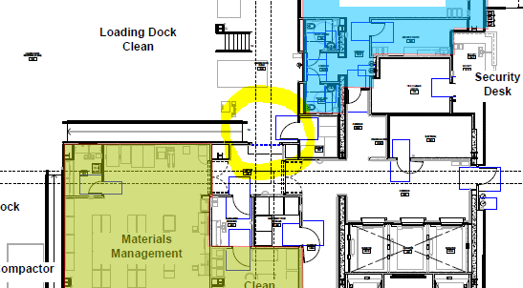
* Soiled linen will be stored in room 1308 and will exit the building through the designated “Soiled” exit pathway as shown in the diagram below.
  + 